PAPER TITLE (in the mother tongue)
(16-point type size, upper- and lower-case, bold and centered)
PAPER TITLE (in english)
(16-point type size, upper- and lower-case, bold and centered)
Autor Name¹, Meno Autor Name², Meno Autor Nam e³ (mother tongue)
¹Autor Name, Institution, Address, Affiliation Country, E-mail
²Autor Name, Institution, Address, Affiliation Country, E-mail
³Autor Name, Institution, Address, Affiliation Country, E-mail
(10-point type size, upper and lower case, centered under the title)

Autor Name¹, Meno Autor Name², Meno Autor Nam e³ (en)
¹Autor Name, Institution, Address, Affiliation Country, E-mail
²Autor Name, Institution, Address, Affiliation Country, E-mail
³Autor Name, Institution, Address, Affiliation Country, E-mail
(10-point type size, upper and lower case, centered under the title)

Abstract (mother tongue):
Your paper should be in the same format as this file. The abstract goes here. Your abstract should be a maximum of 500 words here clearly outlining the contribution of your paper.
For the abstract use Times New Roman font, italics, 10-point type size, centered.
Abstract abstract abstract abstract abstract abstract abstract abstract abstract abstract abstract abstract abstract abstract abstract abstract abstract abstract abstract abstract abstract abstract abstract abstract abstract abstract abstract abstract abstract abstract abstract abstract abstract abstract abstract abstract abstract abstract abstract abstract abstract abstract abstract abstract abstract abstract abstract abstract abstract abstract abstract abstract abstract abstract abstract abstract abstract abstract abstract abstract abstract abstract abstract abstract abstract abstract abstract.

Key words (mother tongue): Maximum six key words.

Abstract (EN)
Your paper should be in the same format as this file. The abstract goes here. Your abstract should be a maximum of 500 words here clearly outlining the contribution of your paper.
For the abstract use Times New Roman font, italics, 10-point type size, centered.
Abstract abstract abstract abstract abstract abstract abstract abstract abstract abstract abstract abstract abstract abstract abstract abstract abstract abstract abstract abstract abstract abstract abstract abstract abstract abstract abstract abstract abstract abstract abstract abstract abstract abstract abstract abstract abstract abstract abstract abstract abstract abstract abstract abstract abstract abstract abstract abstract abstract abstract abstract abstract abstract abstract abstract abstract abstract abstract abstract abstract abstract abstract abstract abstract abstract abstract abstract.

Key words (EN): Maximum six key words.

Paper title, Abstract, Key words- maximum of one page A4 – required oblique of page !

1 Introduction

Introduction text
Introduction text

Clearly explain the nature of the problem, previous work, purpose, and contribution of the paper.

2 Body paper

For the body of your document, use Times New Roman font, 12-point type size, single-spaced. The whole document should be fully justified (not only left-justified).

- Paper size: A4 (210 mm by 297 mm).
- Margins:
-Top of first page 2.5 cm
-Bottom, left, and right 2.5 cm
-Subsequent pages for top, bottom, left, and right 2.5cm.

Headings should be 14-point, upper- and lower-case, bold. Subheadings should be 12-point upper- and lower-case, bold.

Title 1
Title text 1
Title text 1

Subtitle
Subtitle text
Subtitle text

2.1 Graphs, Tables, and Photographs

Tables and Graphs: Minimum 8-point type size, all captions should be upper- and lower-case, bold, and centered over page.

Illustrations and Photographs: Halftones, minimum of 8-point type size. Captions should be in upper- and lower-case, bold, and centered over page. Images must be computer-designed and submitted as EMBEDDED images in your document.

Tab. 1 – Description of items for individual years
Name of items | Year | Value

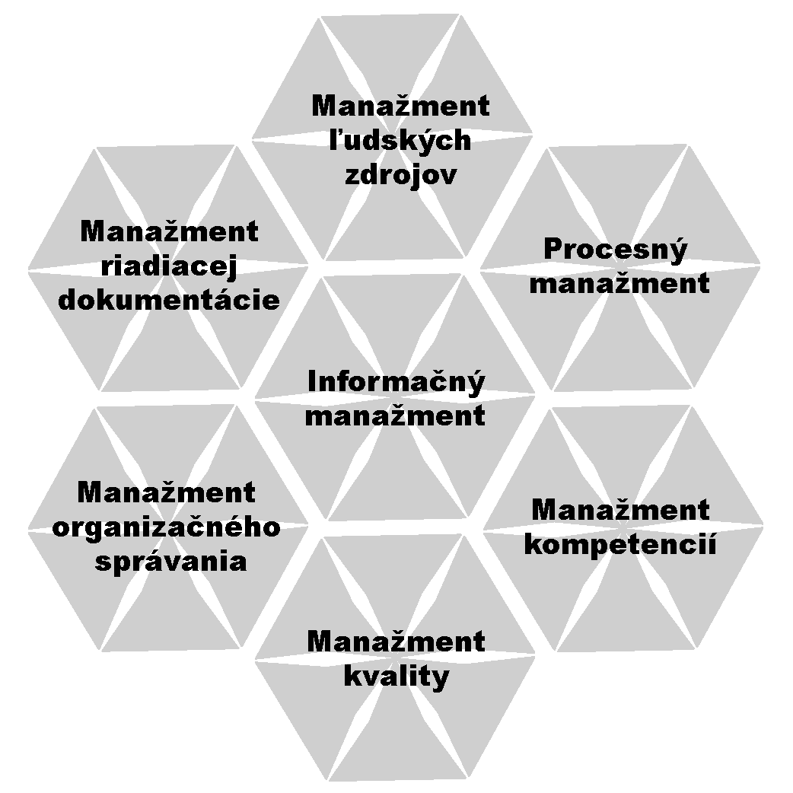

Fig. 1 - In look Days (Source: Custom processing)

Patterns: should be centered and use italics. If you refer to some patterns, you should numbered them in round brackets. An example relationship by [33]

$o_{4}=\frac{I⋅c_{1}\left(1+p\right)}{1−M−e}$ (76)

If there is multiplication in formula, give the mathematical symbol. Otherwise, it may be difficult to read.

3 Conclusion

Clearly indicate advantages, limitations, and possible applications.

Literature (References)

References need to be numbered as they appear in your text ([1], [2], [3], etc) and should appear in your reference section in numerical order (not alphabetically).

[1] Železník, O.: The parent organization of the production process model. In: Organisational structures and management documentation: Proceedings of the workshop: Horizont Hotel, Stará Lesná, 18.-19th October 2007. Košice : INTER M & K, 2007. 7 p. ISBN 978-80-969804- 9-9.
[2] Kapteyn, A., Kooreman, P., Willemse, R.: Some Methodological Issues in the Implementation of Subjective Poverty Definitions. In: The Journal of Human Resources. Vol. 23, No. 2 (Spring, 1988), pp. 222 – 242.
[3] Ravallion, M.: Poverty comparisons: A guide to concepts and methods. Washington, D. C.: The World Bank, 1992. ISBN 0-8213-2036-X.

